Daily menu
1st Day
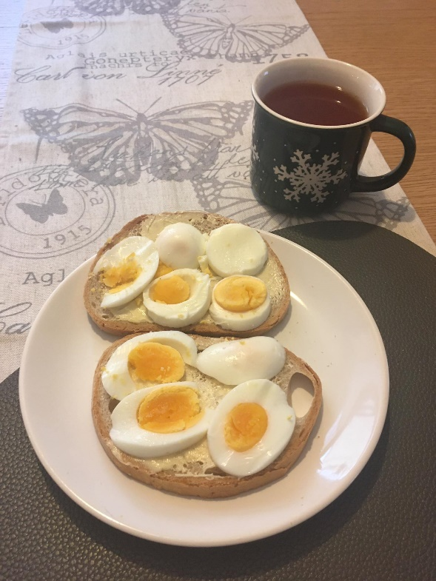
Lunch – bread with slices of egg and tea with lemon.
Ingredients:
1.Two slices of bread
2.Two boiled eggs
3.Black tea with a slice of lemon

2nd Day

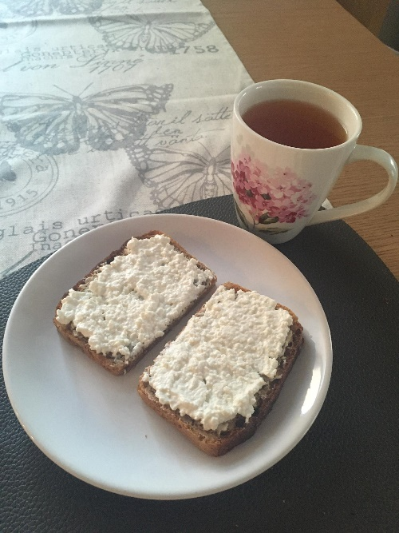
Breakfast – sandwiches made of wholemeal bread with cottage cheese and lemon tea.
Ingredients:
1.Two slices of wholemeal bread
2.Cottage cheese
3.Black tea and a slice of lemon

3rd Day
Breakfast - Bread with cottage cheese and black tea.
Ingredients:
1.Two slices of bread 2.Cottage cheese 3.Black tea

4th Day
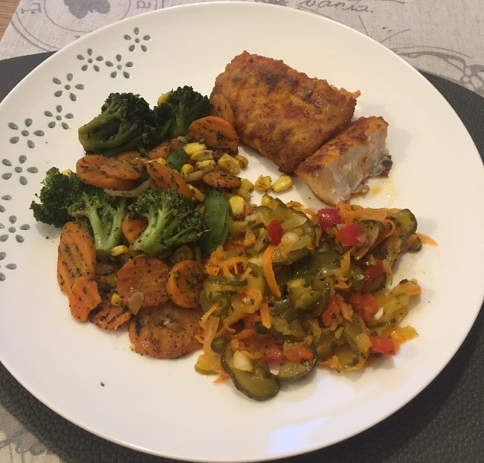
Dinner – Cod served with vegetables like carrots and broccolies and vegetable salad containing peppers and cucambers.
Ingredients:
1.Cod fillet
2.Vegetables to cook (slices of carrots, broccolies)
3.Vegetable salad
5th Day
Sandwich with salad, cheese and pepper.
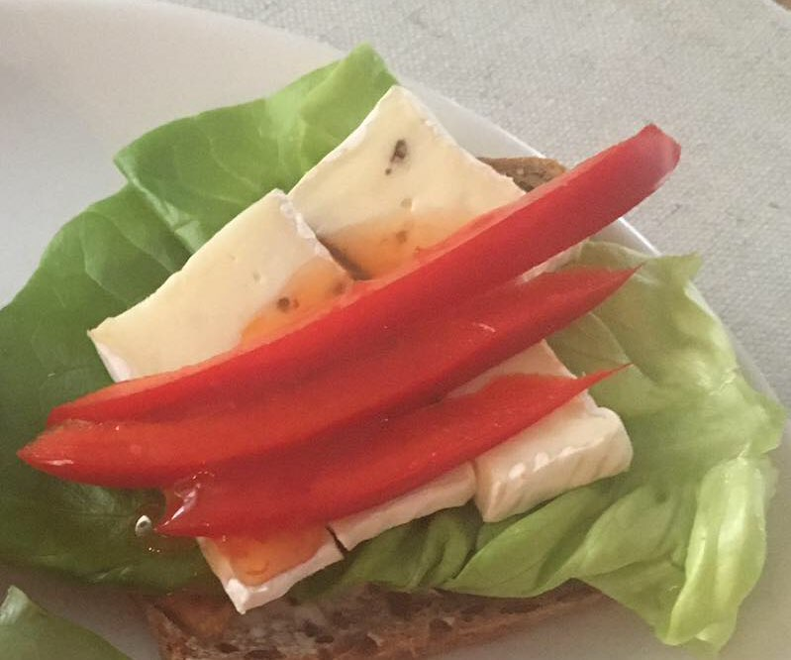 by Maja
Ingredients:
1.Slice of bread
2.Slice of cheese
3.Pepper

