My daily menu

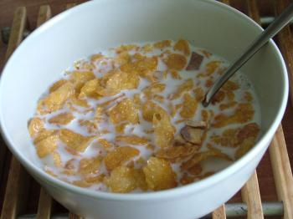
Monday - Breakfast
For breakfast I have cereal like I usually do. I like it because they are easy to prepare and tasty. Once a week I eat pancakes or waffles for breakfast. I always drink a glass of orange juice too.

Tuesday - Lunch
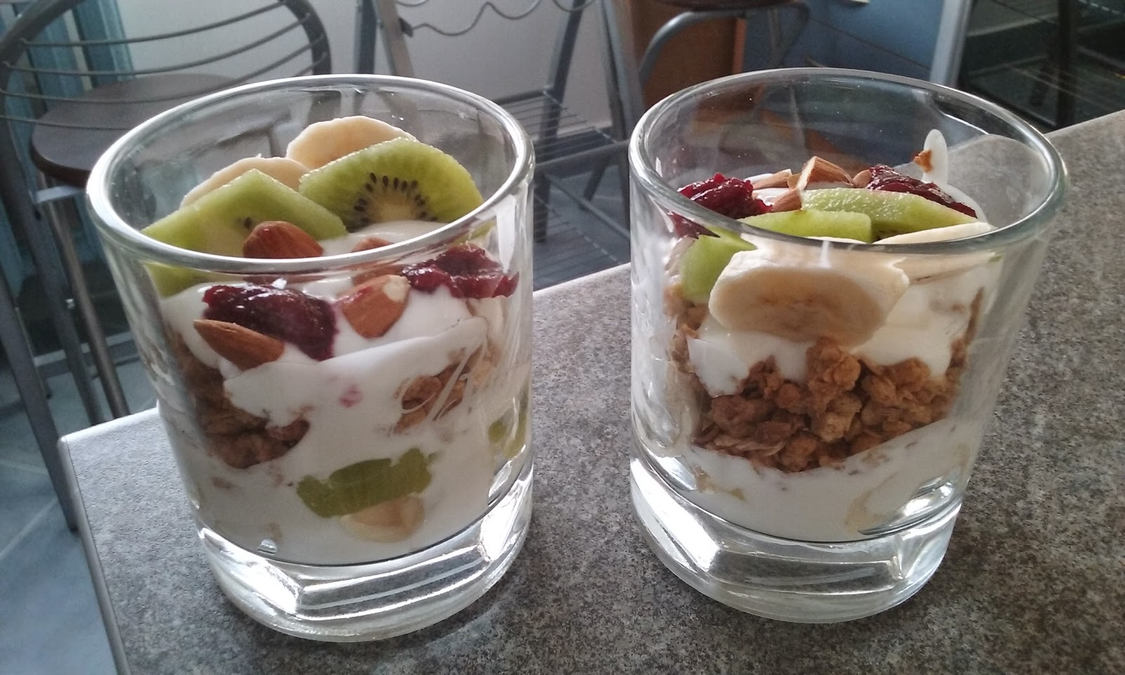
For lunch I have yogurt with muesli and fruits.
Sometimes I have a fruit salad or some sandwiches for lunch and I really like them. I drink a lot of water as well.

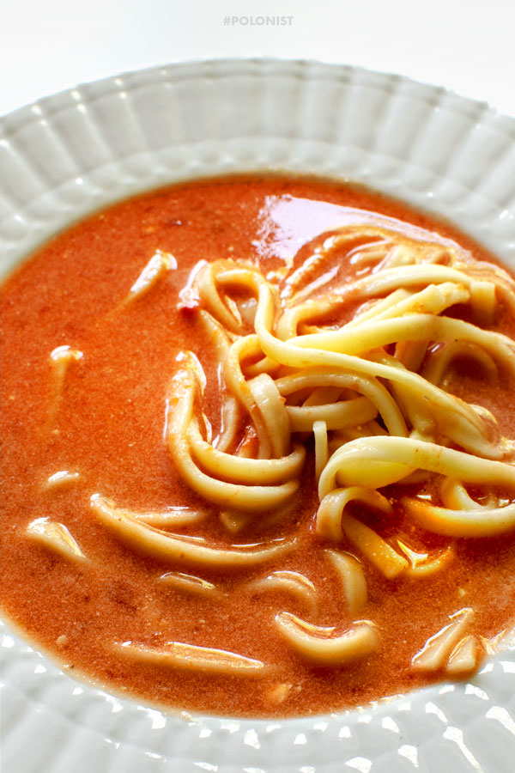

Wednesday - Dinner
For dinner I have tomato soup with pasta, but usually I eat different kinds of pasta or other soups e.g. eevery Sunday I eat chicken soup. Sometimes my mom prepares lassagna for dinner and it is delicious.

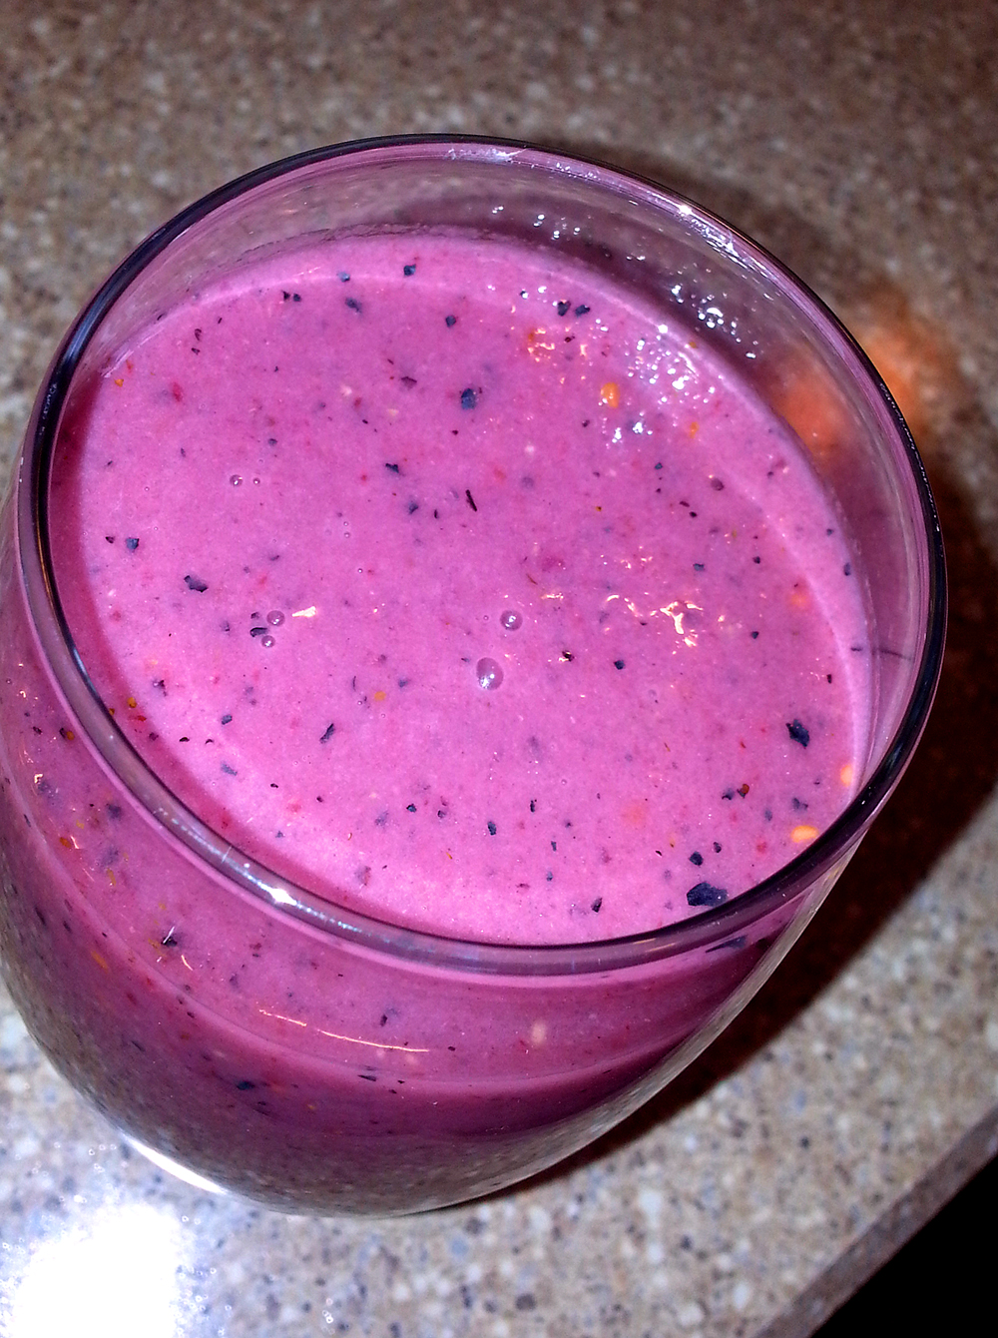
Thursday - Tea / Dessert
Usually I don’t eat dessert but when I do I often eat something like muffin, my mom’s apple pie or smoothie. I drink a lot of tea with honey and lemon during tea time.

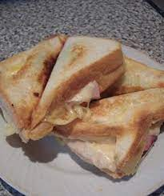
Friday - Supper
For supper I usually eat sandwiches with ham and tomato, toast or porridge with bananas, apples and some honey.
There is one thing that I like the most - scrambled eggs with tomatoes and cucumbers.
Yummy

