My daily menu
- Breakfast
I usually eat breakfast at 9 a.m.
I eat different things, but usually I try to eat healthy breakfast that consists of musli and fruits.
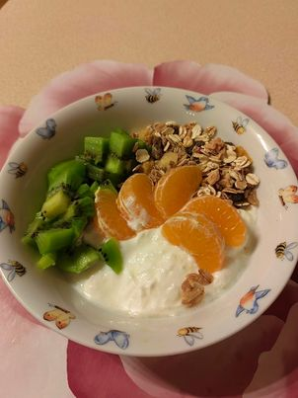

- Lunch
I eat lunch at 12 a.m. I sometimes eat something sweet to have energy for the rest of the day.
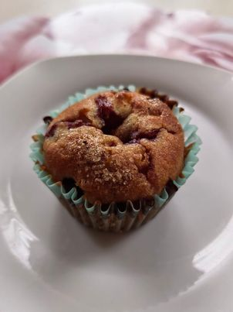
- Dinner
I have two courses for dinner . First course is a broccoli soup made by my mum. It is delicius.
Main course is meat with groats and vegetables. It is really healthy dinner with a lot of vitamins.
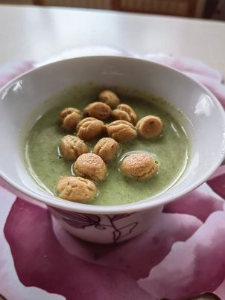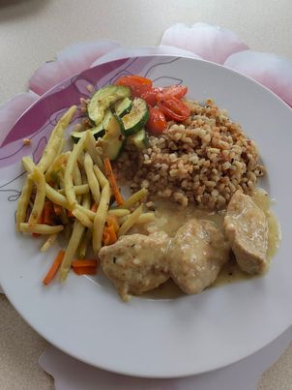

By Amelia

