MY DAILY MENU
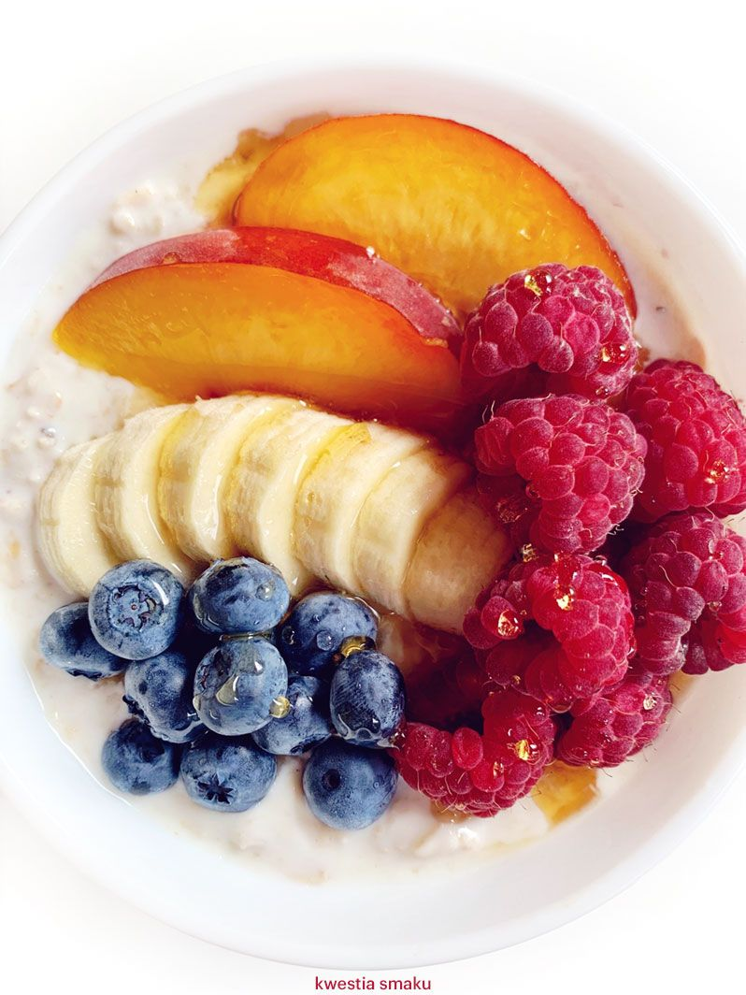
Breakfast For my breakfast I have porridge with peanut butter. On the top I put a sliced banana, rasberries and I sprinkle some coconut. Its very easy and quick to do.

Lunch
For lunch I eat toast, with avocado paste, ham and some eggs. I also made a juice with orange, carrots and apples. If you don’t have time to do juice you can buy it in shop but remember to check the ingrediens.

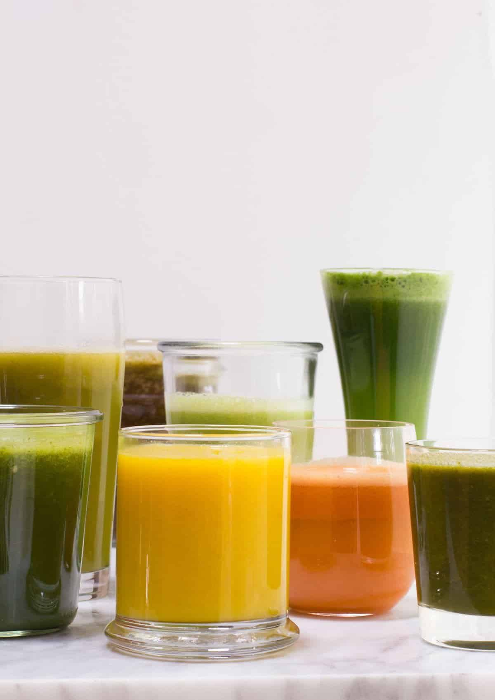
Dinner
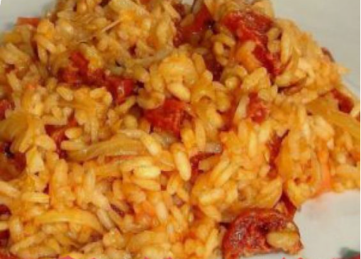
For dinner I have just one course. I eat a meal called risotto. Its a rice with chicken and I put there pepper for better taste. You can put there a different types of pepper (eg. Red, green, yellow) but unfortunatelly I have just red one.

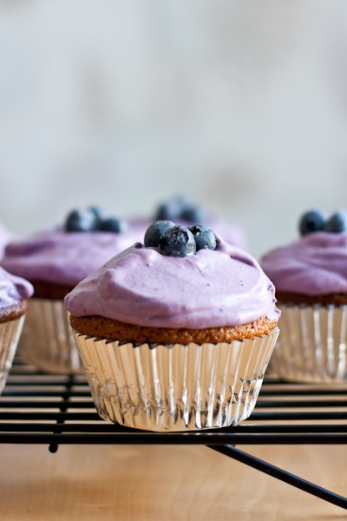
Afternoon tea
For my afternoon tea I always eat some pie or cookies that I made by myself. If I don’t have time to eat anything I just drink tea. Today I have eaten vanilla cupcakes with blueberries. I have had a glass of milk as well.

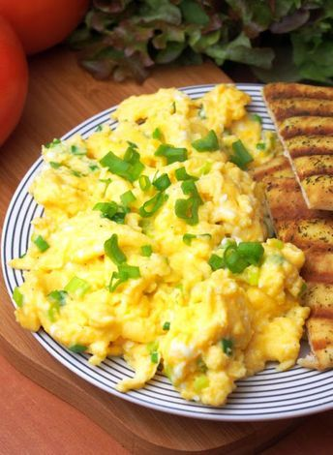
Supper
For my supper I have scrambled eggs with chives and a sandwich with cheese and tomatoes. I also have a tea with lemon and rasberry juice.

