MY DAILY MENU

Breakfast
For breakfast, I always eat cereal with hot milk, waffles with strawberries
and hot black tea. I know breakfast is the most important meal of the day.
Lunch
For lunch, I usually eat Cesar salad with parmesan cheese. Sometimes I also like to eat mushroom soup with garlic bread.
Dinner
For dinner, I eat grilled salmon French fries, and coleslaw. I like this meal because it’s healthy and delicious.
Dessert
My favorite dessert is a cake with some fruit and whipped cream.
Supper

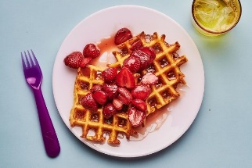
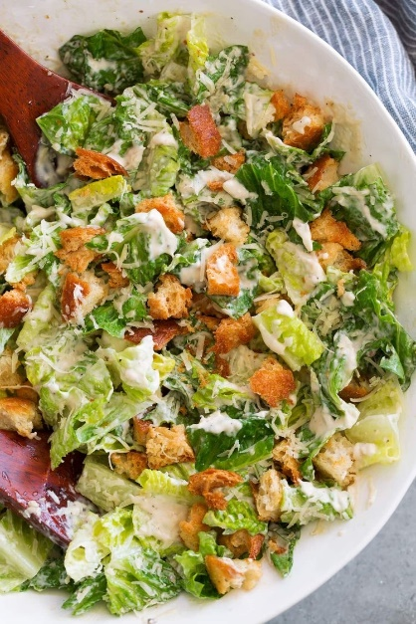
For supper, I eat tacos. It is made from meat, lettuce, cheddar cheese, cucumber, and avocado. All of these ingredients are inside a corn tortilla. That’s my favorite dish from Mexican cuisine.
