**Healthy daily menu**

* **Breakfast**

For the Muesli I use frozen fruits: raspberries and blueberries, roast spelt, yoghurt, peanut butter and little peanuts. As a first step I crumble peanuts. Then I combine the peanut butter with little water and add some salt tothe mixture. Having this ready I get other ingredients out. At the end I mixed it all.

* Brunch

This is a Bruschetta. It is a traditional Italian meal. To make it I use tomatoes, a roll, olive oil, garlic and basil. As a first step I cut the roll in half and put it away. Having this ready I cut each tomatoes in half, put them in the bowl and added a little bit garlic and basil. At the end I spread the mixture on the halves of bun.

* Dinner

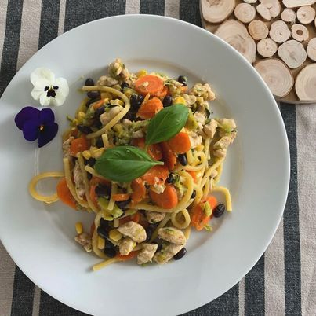

For dinner I ate the pasta. To make it I use thick spaghetti, chicken, black bean, corn, carrot, courgette, avocado, leek, garlic and lemon juice. As a first step I fried slices of carrot, courgette, leek and chicken and added a little bit of salt and pepper. Then I smashed avocado with lemon juice and added spices such as basil and olive oil. After that I boiled the pasta. At the end I mixed all ingredients together